Setup Custom linux OS Yocto Project and build a custom Linux image (core-image-minimal) using **BitBake**.

Follow below steps:

Step1:

1. **I need to create aws Ubuntu Server. Choose the version below in aws.**

**Ubuntu Server 22.04 LTS (HVM), SSD Volume Type (64-bit (x86))**

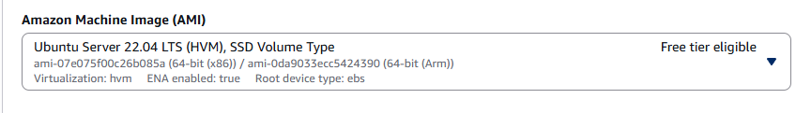

1. **Select t3 small instance type ( free tire eligible)   
   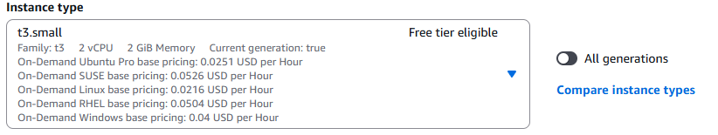**
2. **Create new key pair ( select after create)**

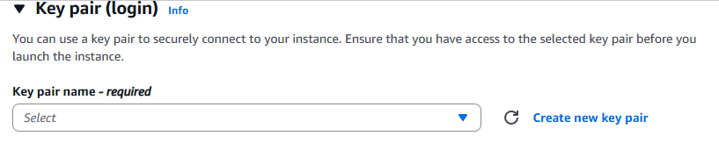

1. **Select network settings**

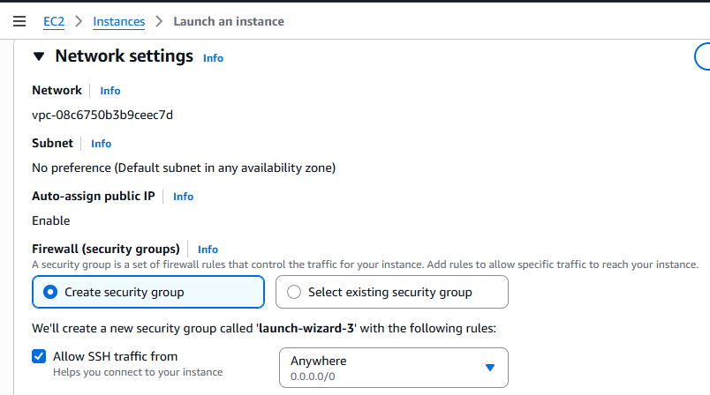

1. **Setup configure storage**

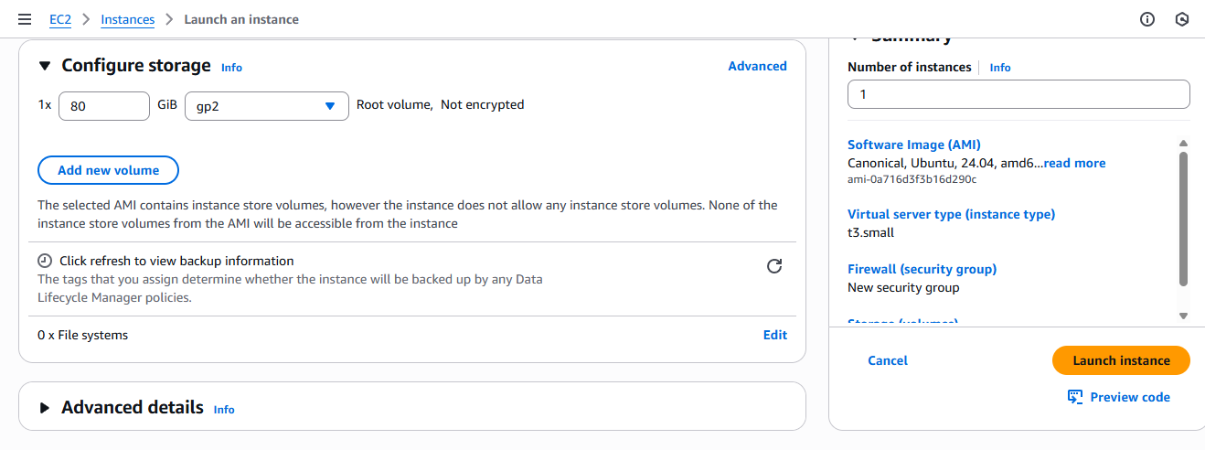

1. **Click on launch instance: ubuntu server has been created.**

Step2:

1. **how to connect aws ubuntu server:**

Run the below command in git bash.

ssh - i /c/users/kasev/downloads/.pem key ubuntu(username)@ipadress of aws ubuntu server  
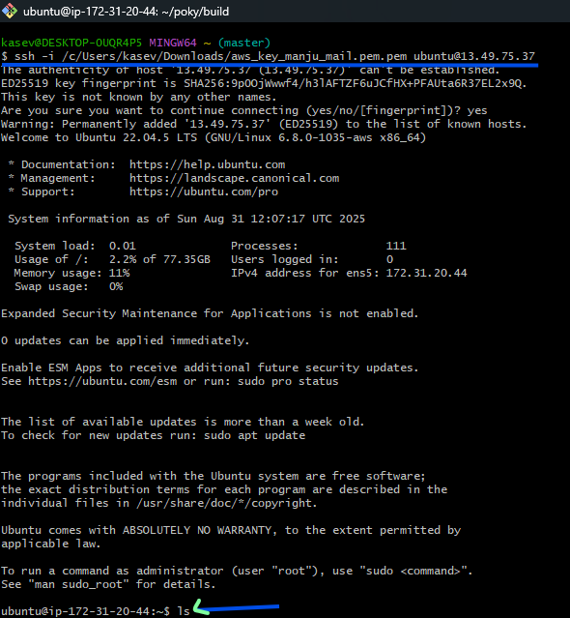

**Once connected to the ubuntu server run below syntax to** build a custom Linux image in ubuntu server.

1. lsb_release -a to Check Ubuntu version and flavor
2. sudo apt update && sudo apt upgrade -y
3. Once run above cmd, will get below kernel version upgrade output.
4. 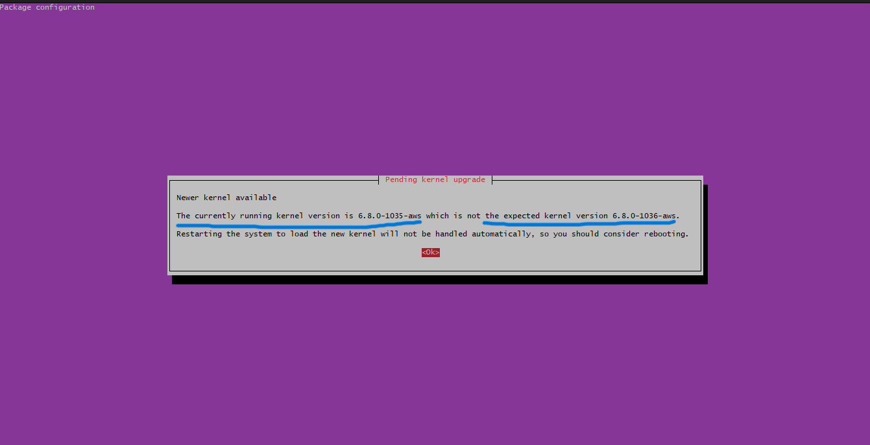
5. sudo reboot
6. uname -r
7. sudo apt update

sudo apt install -y \

gawk wget git diffstat unzip texinfo gcc-multilib \

build-essential chrpath socat cpio python3 python3-pip \

python3-pexpect xz-utils debianutils iputils-ping \

python3-git python3-jinja2 libegl1-mesa libsdl1.2-dev \

pylint xterm

1. sudo fallocate -l 4G /swapfile
2. sudo chmod 600 /swapfile
3. sudo mkswap /swapfile
4. sudo swapon /swapfile
5. swapon --show
6. echo '/swapfile none swap sw 0 0' | sudo tee -a /etc/fstab
7. free -h
8. cd ~
9. Ls
10. Pwd
11. git clone git://[git.yoctoproject.org/poky](http://git.yoctoproject.org/poky)
12. cd poky
13. Pwd
14. git checkout scarthgap
15. git branch
16. source oe-init-build-env
17. cd ..
18. Ls
19. cd build/
20. bitbake core-image-minimal
21. 
22. sudo apt update
23. sudo apt install lz4
24. bitbake core-image-minimal

